FLEX

FLEX (fast lexical analyser generator) is a tool/computer program for generating lexical analysers (scanners or lexers) written by Vern Paxson in C around 1987. It is used together with Berkeley Yacc parser generator or GNU Bison parser generator. The description is in the form of pairs of regular expressions and C code, called rules. flex generates as output a C source file, `lex.yy.c', which defines a routine yylex. Compile and link this file with the `-lfl' library to produce an executable. When the executable runs, it analyses its input for occurrences of the regular expressions. Whenever it finds one, it executes the corresponding C code.

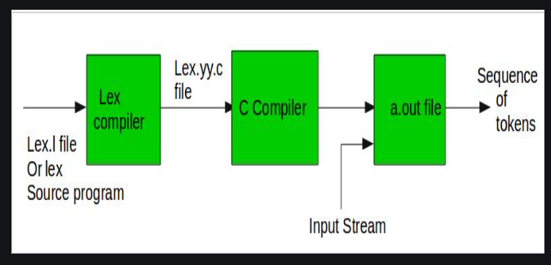

Example

Counting number of lines in the code

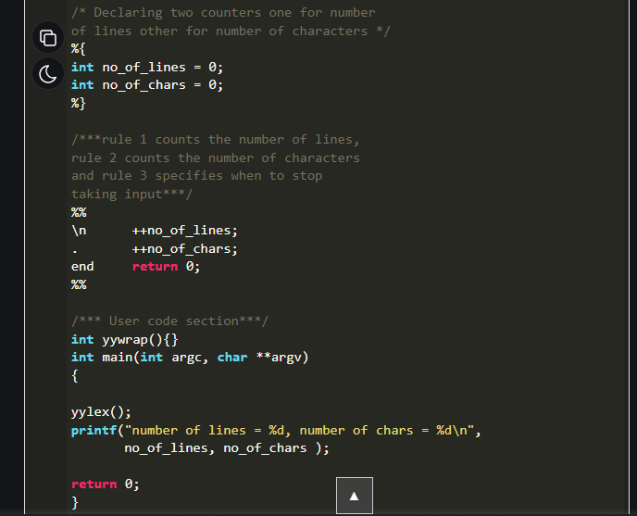

BISON

Bison is a general-purpose parser generator that converts an annotated context-free grammar into an LALR(1), LR(1), or GLR parser for that grammar.  Once you are proficient with Bison, you can use it to develop a wide range of language parsers, from those used in simple desk calculators to complex programming languages. Bison is upward compatible with Yacc: all properly-written Yacc grammars  
ought to work with Bison with no change.  Anyone familiar with Yacc should be able to use Bison with little trouble.

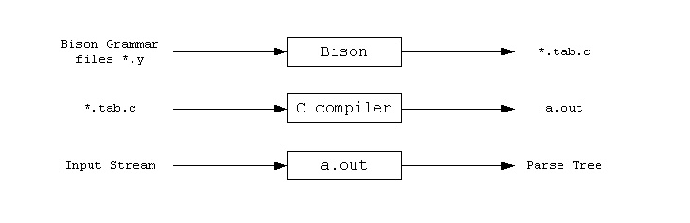

Example

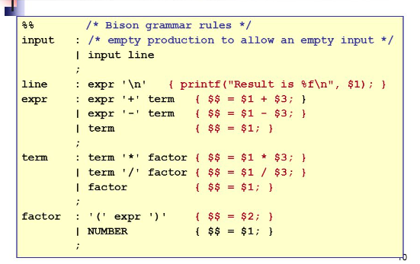

LEX

Lex is a program that generates lexical analyzer. It is used with YACC parser generator.The lexical analyzer is a program that transforms an input stream into a sequence of tokens.It reads the input stream and produces the source code as output through implementing the lexical analyzer in the C program.

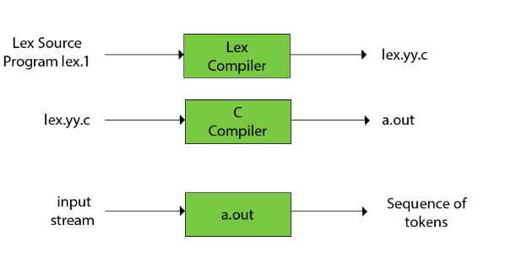

YACC

YACC provides a tool to produce a parser for a given grammar.YACC is a program designed to compile a LALR (1) grammar.It is used to produce the source code of the syntactic analyzer of the language produced by LALR (1) grammar.The input of YACC is the rule or grammar and the output is a C program.

